# Camera

Transform matrix of the camera

Get rid of z

Small triangle

Big triangle

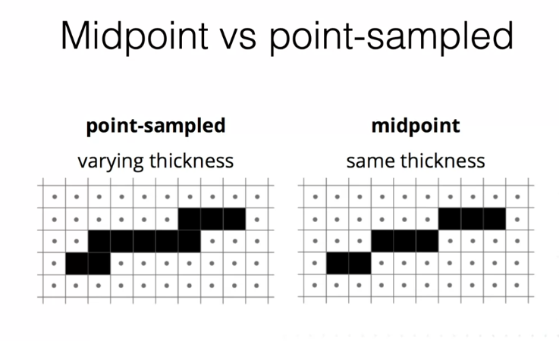

Swap x and y and use the same algorithm

# Hidden Surface Removal

Draw starting from the furthest object

Can be drawn in any order, doesn’t work for transparent object

